**Preloading Modules**

The command line flag **-r** or **--require** can be used to preload a module before anything else loads.

Given a file named **preload.js** with the following content:

**console.log('preload.js: this is preloaded')**

And a file called **app.js** containing the following:

**console.log('app.js: this is the main file')**

The following command would print **preload.js: this is preloaded** followed by **app.js: this is the main file**:

**node -r ./preload-me.js app.js**

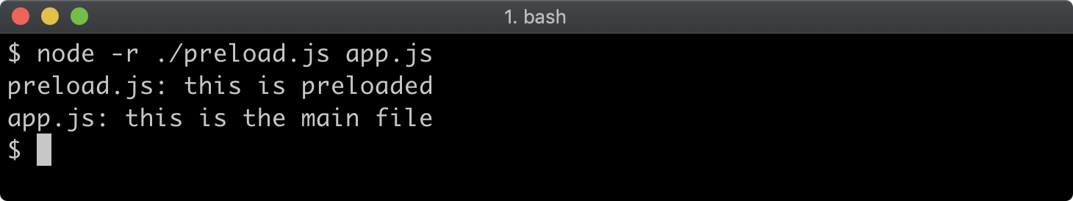

Preloading modules is useful when using consuming modules that instrument or configure the process in some way. One example would be the [dotenv](https://www.npmjs.com/package/dotenv" \l "preload" \t "_blank) module.